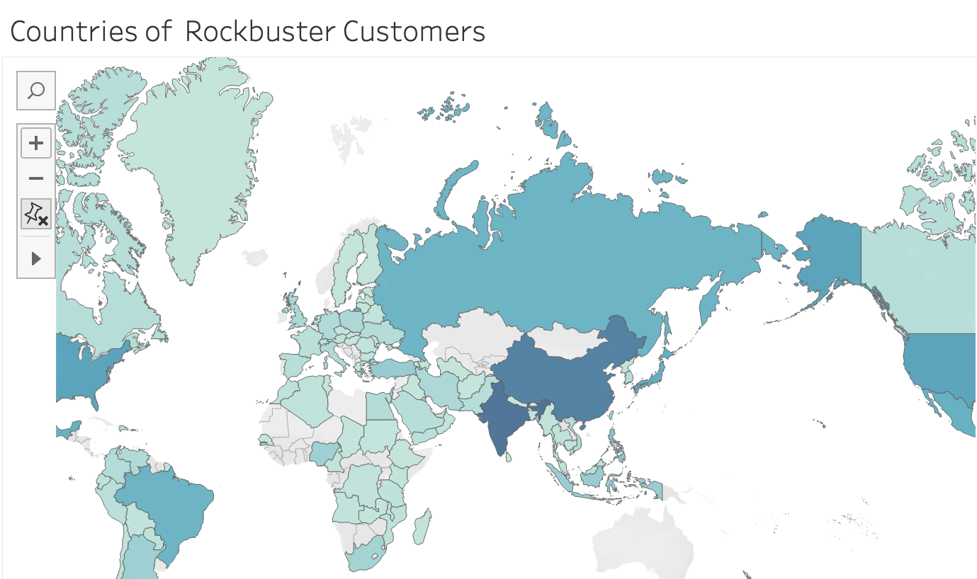 Top 3 countries with most

customers base –

* India
* China
* United States